The Maria-Helena Foundation
(Registered Charity Number 89250 2725 RR0001)
4616 West 13th Avenue, Vancouver, B.C. V6R 2V7
Telephone: (604) 228-9885 e-mail: iqbal@interchange.ubc.ca
www.mariahelenafoundation.org

Annual Newsletter Fall 2009
Dear Family & Friends:

As you know, our mandate is to provide educational and medical aid to poor families in South Asia, and offer bursaries to qualified university students in financial need in Canada. Over the past several years we have concentrated mainly on providing educational aid and skills training to the poor in Pakistan. All our projects are in Pakistan and are in partnerships with local non-governmental organizations (NGOs). The Bursary Fund at the University of British Columbia is continuing. Below we present highlights of the new projects and updates on the existing ones.
IN PAKISTAN: EDUCATION
We provide educational aid by helping to build permanent self-sustaining primary schools, establishing temporary primary one-room home-schools, and offering half-fee scholarships to children from poor families registered in schools that we helped build, as well as to children in other schools.
- Permanent Primary Schools. Typically, the local community provides the land. We pay for construction of the school building, as well as for furniture and equipment. This costs us a total of somewhere between $70,000 and $80,000. Our Pakistani partners manage the schools, charging low fees and covering the operating losses by donations collected locally. In these schools, which are self-sustaining after building has been completed, tuition fees are generally about $4 per month, and teachers’ salaries are between $30 and $50 a month. All schools are co-educational and non-sectarian, and the teachers are almost exclusively women. We have helped establish ten such primary schools, and helped reconstruct one demolished school in the area affected by the 2005 earthquake. On page 3 is a table of all schools completed, and planned.
- Temporary Primary Home-Schools. These are one-room, one-teacher schools meant for the poorest children and for working children. Classes are held at the teacher’s home or in a community building. Students do not pay any fees. We provide them with books, notebooks, and mats or benches to sit on, and also pay the teacher's salary. All schools are co-educational and non-sectarian. In the Pakistani school system, the primary school academic program is five years. In the home-school system, due to fewer holidays, the same curriculum is covered in 36-40 months. Typically, the cost of supporting one such school of 20 to 30 students is about $1,200 per year. Currently, we are sponsoring 11 such schools in partnerships with one NGO, see table on page 3.
- Scholarships. This is an ongoing program for primary school children, which offers half-fee scholarships valued at $2 per month per student. Currently, 190 scholarships are being offered in 16 different schools.
*New: The Maria-Helena Foundation has partnered with a local youth NGO to provide scholarships for high school students in Pakistan. Donations as small as $20 can me made online by visiting www.educationgeneration.com. Sorry, tax receipts cannot be issued for these online donations.
IN PAKISTAN: SKILLS TRAINING
We have helped establish two small vocational schools in which young girls and women learn traditional needlecraft and sewing. This training helps the invisible household economy of poor families, and can potentially generate income from outside work.
1. Nani Maria Vocational School, Lahore (2000). In this three-room school the enrollment has varied from 20 to 40 students. Al-Khidmat Foundation manages this school.
2. Dr. Marilyn Mohan Vocational School, Pind Dadan Khan (2007). This one-room vocational centre is located in one of our new primary schools.
IN PAKISTAN: HEALTH
Amina Jabbar Trust Hospital, Lahore (1998). This, our first project, is an outpatient hospital, the size of a single-family detached bungalow in Vancouver. It is managed by Al-Khidmat Foundation. About 80 patients per day receive a medical examination and 3 days of medication at a nominal cost of 15 cents per patient, about one-sixth the cost of private care.
IN CANADA: BURSARY
The Maria-Helena Bursary Fund, University of British Columbia (2000). This year, bursaries were awarded to two undergraduate students. These bursaries are awarded from the income generated from the capital of this fund. The University selects the recipients.

Thank you all for your continued support and prayers. Let us know if you have any questions. We would like to wish you all the best at Christmas, and happiness in the New Year.

Dr. Muhammad Iqbal Dr. Diane Fast
President Vice-President

The Maria-Helena Foundation
(Registered Charity No: 89250 2725 RR0001)
4616 West 13th Ave Vancouver, B.C. V6R 2V7

Amount of Donation: $_____________(Make cheques payable to The Maria-Helena Foundation)
Please indicate: For projects in Pakistan_________, or for bursary at UBC________, or for both____________

Family Name:__________________________________First Name:__________________________________
(Please print legibly, thank you)
Address: _____________________________________________________________________________

________________________________Postal Code:___________________________________

Telephone: (_________)__________________e-mail____________________________________________

PERMANENT PRIMARY SCHOOLS

Name of School | Year Established | City (Village) Province | No. of Students | Pakistani Partner
1. Fazal Noor Primary School | 2000 | Lahore (Kot Lakhpat)  Punjab | 400 | Al-Khidmat
2. Haji Bostan Primary School | 2001 | Lahore (Ghaziabad)  Punjab | 300 | Anjuman  Ghaziabad
3. Dadi Helena Primary School | 2004 | Lahore (Dina Nath) Punjab | 400 | CARE
4. Maria-Helena Primary School | 2006 | Jhelum (Daryala Jalip) Punjab | 300 | Tameer-e-Millat
5. Hazara TM Public School  (combined primary and high school rebuilt after the 2005 earthquake) | 2007 | Shinkiari  North West Frontier  Province | 450 | Tameer-e-Millat
6. Ratwal Residential Primary School  (For orphans of the 2005earthquake. We provided six classrooms) | 2008 | Islamabad  (Ratwal) Punjab | 200 | Tameer-e-Millat
7. Maria-Helena Primary School | 2008 | Khanewal  (Wajhianwala) Punjab | 210 | Tameer-e-Millat
8. Maria-Helena Primary School | 2008 | Jhelum  (Pind Dadan Khan)  Punjab | 300 | Tameer-e-Millat
9. Maria-Helena Primary School | 2008 | Jhelum  (Lilla village) Punjab | 300 | Tameer-e-Millat
10. Maria-Helena Primary School | 2009 | Jhelum  (Jethal village) Punjab | 300 | Tameer-e-Millat
11. Maria-Helena Primary School | 2009 | Jhelum  (Wara Buland) Punjab | 300 | Tameer-e-Millat
12. To be named | In Planning Stage | Punjab |  | Tameer-e-Millat

TEMPORARY PRIMARY HOME-SCHOOLS

City (Village)  Province | Year Established | No. of Schools | Locale | Gender of Teacher | No. of Students | Pakistani Partner
Bahawalnagar  Several villages | 2005  to  2009 | 11 | Mosques/  Private homes | Male | 280 | Kawish Welfare Trust

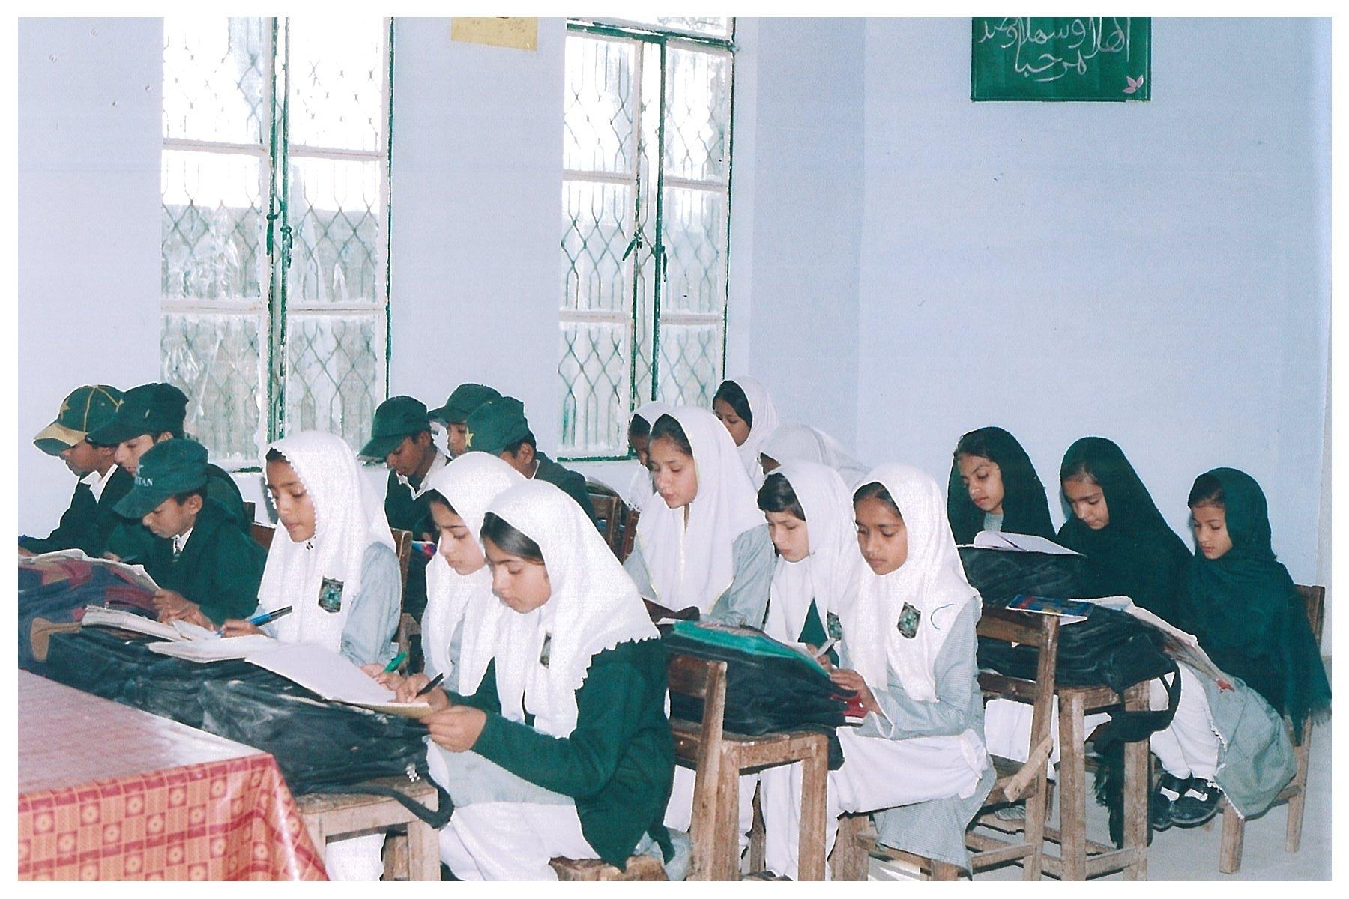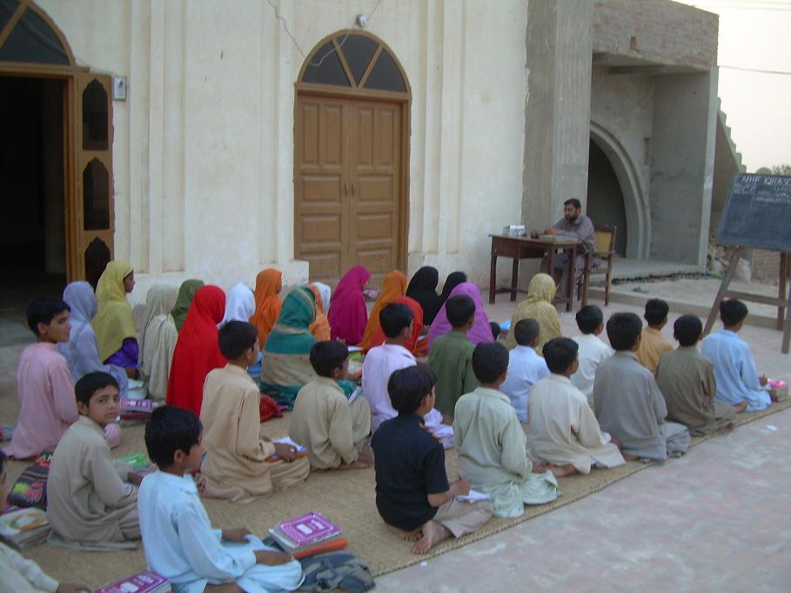
A Glimpse at Our Projects in Pakistan
Permanent co-educational primary school
Temporary co-educational primary school

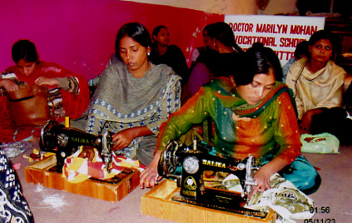
Dr. Marilyn Mohan Vocational School

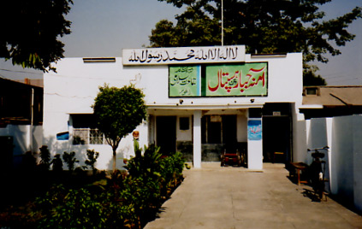
Amina Jabbar Trust Hospital

